# **Mass in Graphic Design**

## **What are the Elements of Design?**

The **elements of design**, rather than being thought of as rules or guidelines, are principles to rely on when designing physical space. The elements of design are the main characteristics of visual imagery, including:

* Line
* Shape
* Form
* Value
* Space
* Color
* Texture

The elements of design are considered and used before designing an object or image in graphic form; designing by determining how to create or communicate a mood or an emotion, or even to produce that mood or feeling within a viewer or observer.

**Mass in Art**

**Mass in art** is used to describe what takes up space and what has weight or volume. Graphic design uses mass to determine what will carry the most significant weight visually. It desires not only to attract the viewer's attention but also to emphasize what is most important and even create a more emotional response. In generic and scientific contexts, **mass** can be thought of as simply an object's matter; it is what an object is made of and, therefore, its weight and volume.

**Mass** is a term heard often in scientific or biological contexts to describe the weighted matter of something or its solid volume. Mass describes an object's composition of matter that takes up space. Conversely, the use of space can be just as intentional;

**Mass** in an artistic and design sense refers more to **visual weight**. How an object appears within a space or how much weight it carries to the eyes rather than to the hands. In this case, size is not the only important factor; color plays a huge role in how much mass an object has. **Red**, for example, is considered the "heaviest" color in terms of visual weight because of its emotional and visual impact. The idea of **mass** in graphic design is that the more weight it carries, the more it will grab and command the attention of its viewer.

## **Shape and Form**

The elements of **shape and form**, although closely linked are defined differently, and even have slightly different functionality and **direction in art**.

**Shape** is essentially just an area of space that can be flat, two-dimensional, or confined by both height and width. Something that has shape is just height and width, even if just one of those elements equals zero.

**Texture and form** are what alter shape by changing the appearance of the object into something three-dimensional. **Form** is just the way a shape occupies space, and forms are three-dimensional. **Objects** in graphic design and art may have the same physical weight but can have differing *visual* weights depending on their shape and form.

Geometric shapes with distinct lines and sharp edges or corners draw the viewer's focus and help emphasize direction in art.

These types of shapes can be considered stronger than round shapes. Straight edges against curves are a powerful contrast, and how lines and curves occupy space and define a shape is essential in understanding mass and visual weight in design.

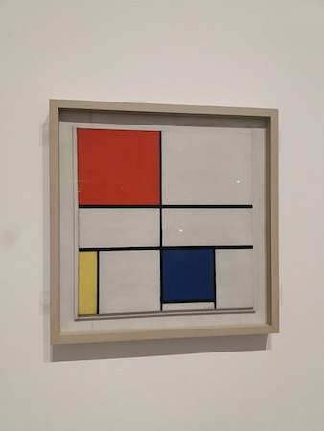

Piet Mondrian used sharp black lines and defined edges to highlight the primary colors of red, blue, and yellow in his classic composition that has been used on clothing, buildings, and in multiple design industries.

## 

## 

## 

## 

## 

## **Color and Focus**

**Color and focus** are used in art to convey a certain mood, inspire a certain reaction, and even just to highlight the most important features. A color's visual weight is dependent on its lightness or darkness, also known as its **value**.

**The value defines** the name of the color, its intensity in brightness, and the darkness and lightness of the tones of color. A depth of intensity in art or mass will draw focus from the eyes of the viewer, which is typically the goal in art and graphic design.

**Naturally, the heavier a color, the heavier the visual weight of an object.** There are dull or muted colors that are less likely to draw focus than highly saturated colors. Combinations of colors can provide a contrast, as can placing objects strategically closer to or further from the main focus of the design. Placing an object further away from the main focus of the design, for example, will make it appear heavier.

## **How to Manipulate Mass**

In graphical design, there are a few golden principles of manipulating mass that can be used to achieve specific goals or cause a certain reaction. These principles include:

* How shapes and forms are aligned in a design
* The balance of weight depending on the number of objects and placement
* The use of contrast between objects or colors
* The proximity of objects from the focal point of the design
* Repetition of certain shapes and forms

Objects in a graphic design can cause an emotional reaction; one would want to make the graphic more appealing by balancing the mass, not crowding anything too closely together, or ensuring appropriate distance between focal objects and other objects.